|  |  |
| --- | --- |
| Team Member Full Name | NetID |
|  |  |
|  |  |
|  |  |

# Chosen Technology Stack

|  |  |
| --- | --- |
| Python + Django | Python + TkInter |

# Persistent Storage Design

***Describe here (in details) how your project is persisting data. Describe its format and schema. Include diagrams. For example: We are using SQLite database to persist our data. Our database includes the tables shown in Figure 1. It contains N tables. The Question table….***

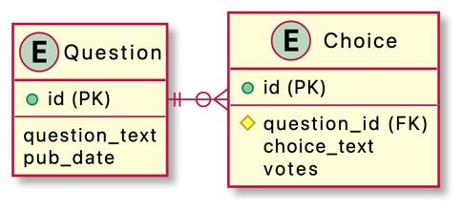

Figure 1 database schema

# Demonstration of the Features

***It should have at least one screenshot per feature. This should include not only the screenshots but also an explanation for them! Make sure the screenshots have good resolution (i.e., they are readable when printed).***

## Feature A

Figure N shows a screenshot for …. Lorem ipsum dolor sit amet, consectetur adipiscing elit, sed do eiusmod tempor incididunt ut labore et dolore magna aliqua. Ut enim ad minim veniam, quis nostrud exercitation ullamco laboris nisi ut aliquip ex ea commodo consequat. Duis aute irure dolor in reprehenderit in voluptate velit esse cillum dolore eu fugiat nulla pariatur. Excepteur sint occaecat cupidatat non proident, sunt in culpa qui officia deserunt mollit anim id est laborum.

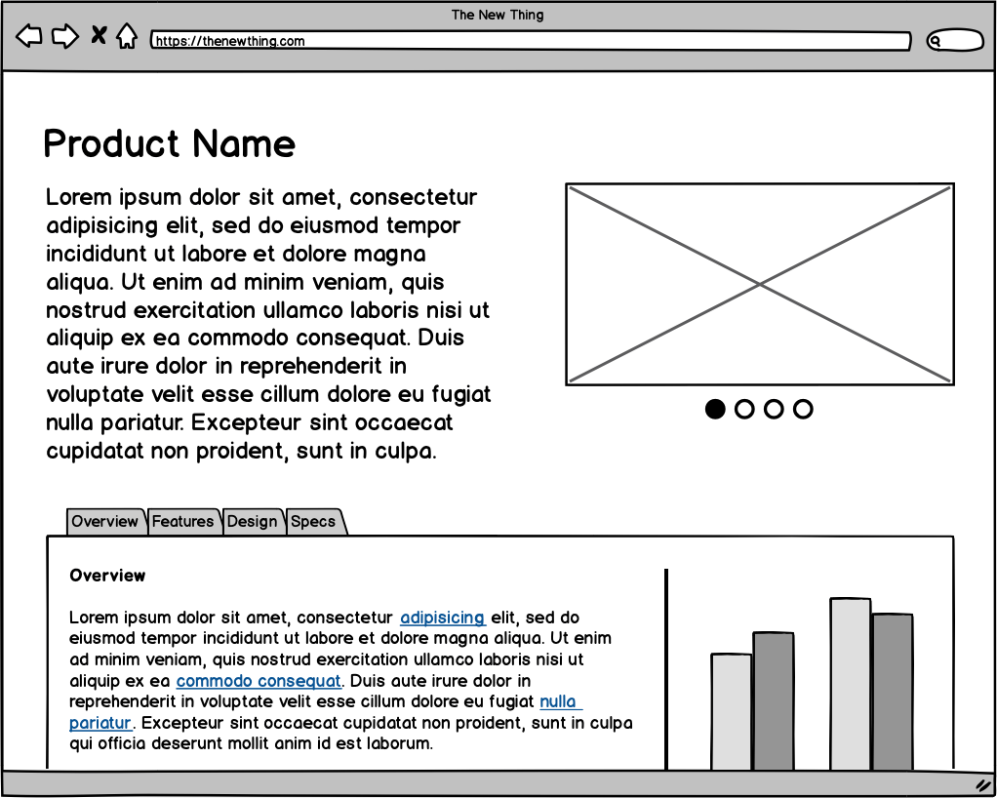

Figure 2 Screenshot for feature A showing ...

## Feature B

Figure N shows a screenshot for …. Lorem ipsum dolor sit amet, consectetur adipiscing elit, sed do eiusmod tempor incididunt ut labore et dolore magna aliqua. Ut enim ad minim veniam, quis nostrud exercitation ullamco laboris nisi ut aliquip ex ea commodo consequat. Duis aute irure dolor in reprehenderit in voluptate velit esse cillum dolore eu fugiat nulla pariatur. Excepteur sint occaecat cupidatat non proident, sunt in culpa qui officia deserunt mollit anim id est laborum.

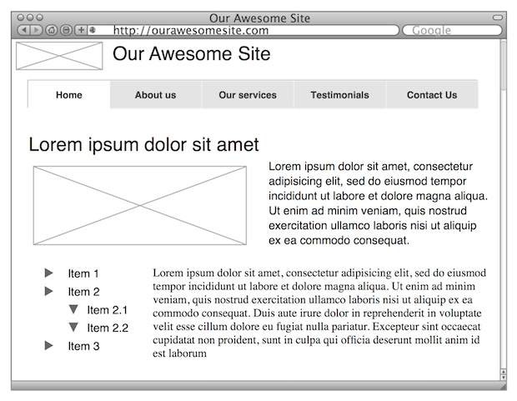

Figure 3 screenshot for feature B

## Feature C

Figure N shows a screenshot for …. Lorem ipsum dolor sit amet, consectetur adipiscing elit, sed do eiusmod tempor incididunt ut labore et dolore magna aliqua. Ut enim ad minim veniam, quis nostrud exercitation ullamco laboris nisi ut aliquip ex ea commodo consequat. Duis aute irure dolor in reprehenderit in voluptate velit esse cillum dolore eu fugiat nulla pariatur. Excepteur sint occaecat cupidatat non proident, sunt in culpa qui officia deserunt mollit anim id est laborum.

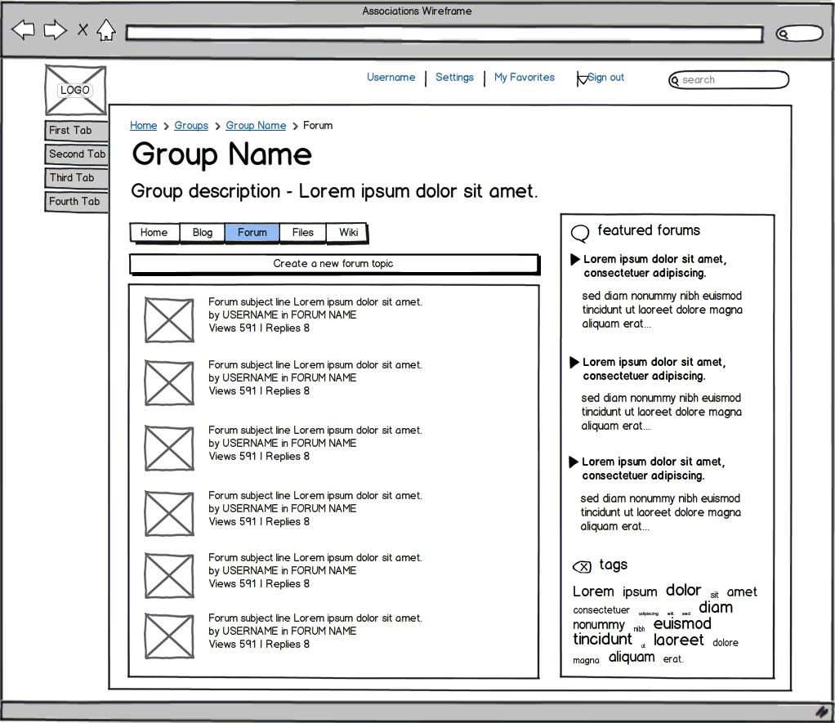

Figure 4 screenshot for feature C

**Project’s Learned Lessons**

***In this section, you will reflect on the group’s activities and performance through the entire project, and capture your reflections, observations and thoughts. It should address the following items, but feel free to expand on these in light of your group’s unique experiences.***

1. ***What programming paradigm(s) have you chosen to use and why? If you were to start the project from scratch now, would you make different choices? Do you think the paradigm(s) chosen helped (or not) in developing the project?***
2. ***Would you plan the release of the project’s features differently? That is, did your plan result in releasing something too early, when another feature could just as well have been include in its stead?***
3. ***Identify risks you encountered, those that never occurred, and problems that arose that you didn’t expect or plan for. How would you want to deal with risk in future projects?***
4. ***What were the most challenging aspects of the project?***
5. ***What aspects of your process or your group’s organization had the largest positive effect on the project’s outcome?***